Lab7: Cassandra Installation

**Prerequisites for Cassandra Installation**

* Java JRE 8
* Python 2.7

**For Windows:**

1. Download and install the latest version of [Python 2.7](https://www.python.org/downloads/).

1.1 Click at the latest version of Python 2.7

1.2 Click download at MSI installer which compatible with your Windows. For example, we are using **Windows X86-64 MSI Installer.**

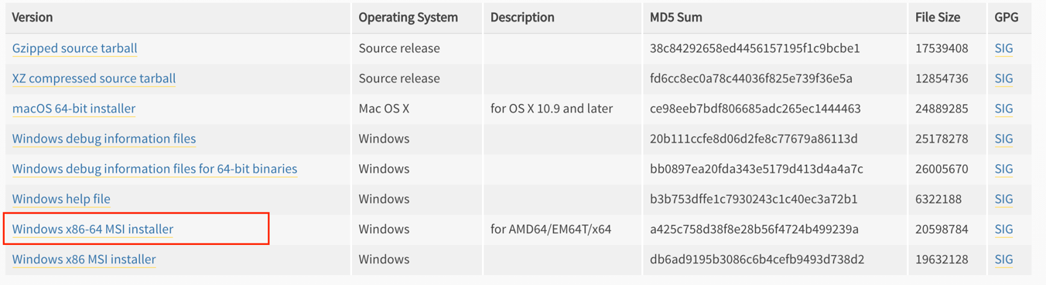

1.3 After the download is finished run the installer. Click accepted the default “Install for all users”. Click **Next**.

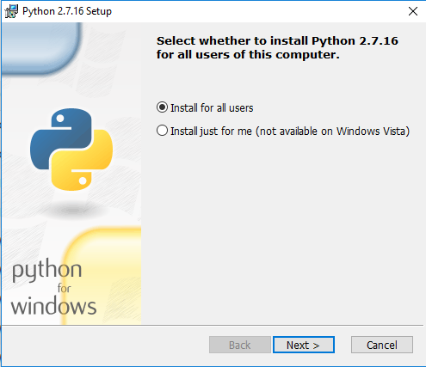

1.4 Select directory for installing Python 2.7 and click Next.

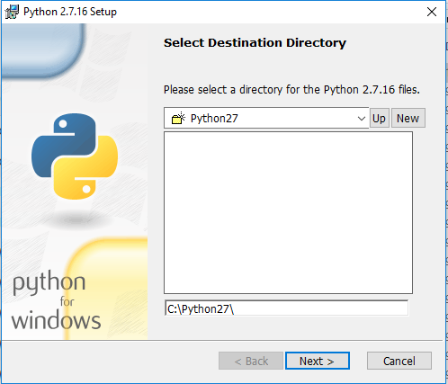

1.5 The installer can set the Python path variable for you. To do this, scroll down to **Add python.exe to Path** and select **Will be installed on local hard drive**. Click **Next**.

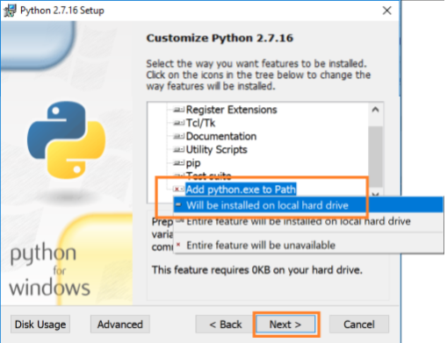

1.6 When it’s done click **Finish**



1.7 Open command prompt and verify python version in your machine,   
type python --version.

2. Download and install the latest version of [Java JRE 8](https://www.oracle.com/technetwork/java/javase/downloads/jre8-downloads-2133155.html).

2.1 Click download file “jre-<version>-windows-x64.exe”.

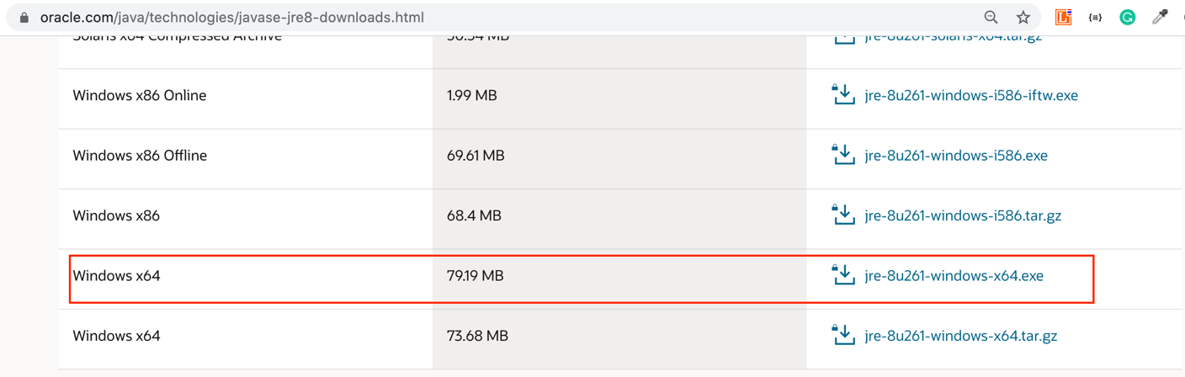

To verify java version in your machine, open command prompt and type java -version.

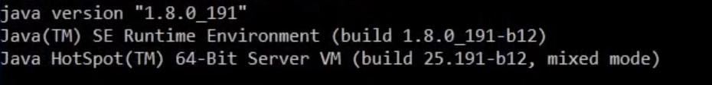

2.2. Set environment variable for Java JRE. Right click at “This PC” and click “Properties”.

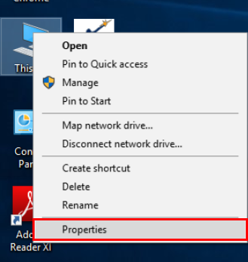

2.3 Go to tab “Advanced” and click at “Environment Variables...”.

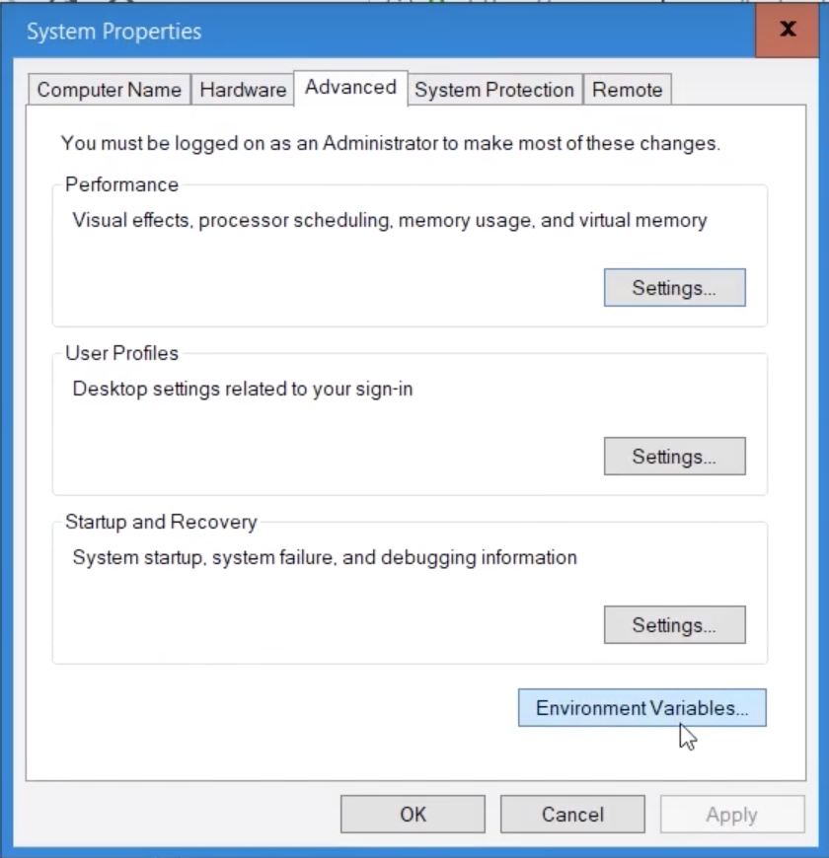

2.4 Click “New...” to create an environment variable.

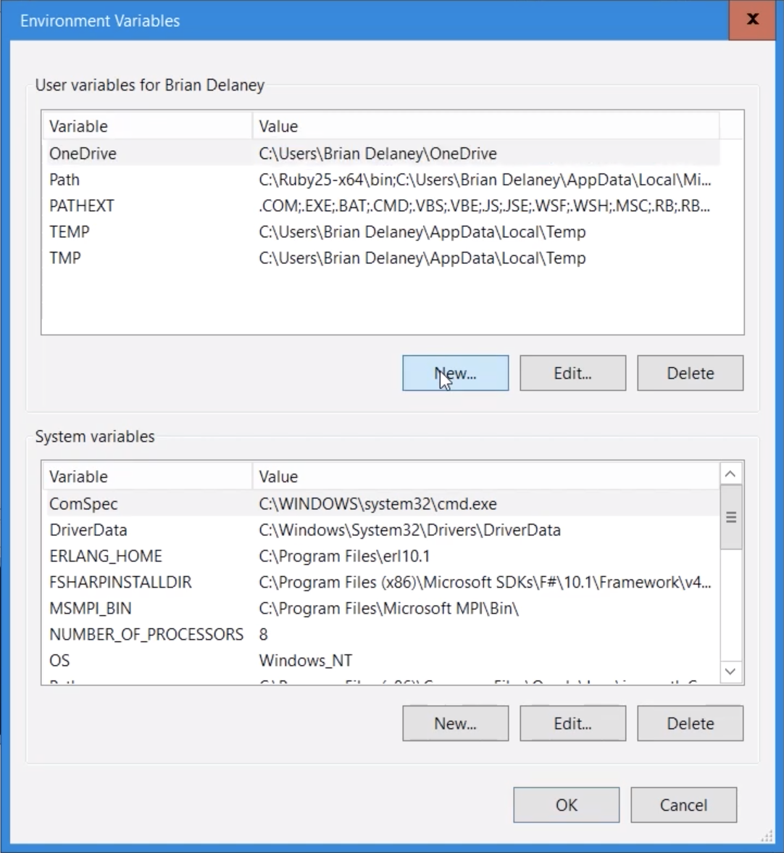

2.5 Set variable name is “JAVA_HOME” and variable value is path of Java JRE. The default of a path file stored Java is “C:\Program Files\Java\<java jre version>”.

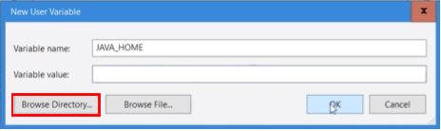

2.6 After selected location path of Java JRE, click “OK”.

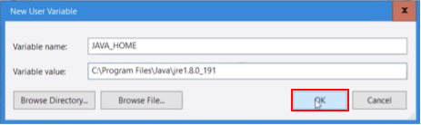

3. Download and Install the latest stable version of Apache Cassandra

3.1 Download the latest stable version of Apache Cassandra at <http://cassandra.apache.org/download/>

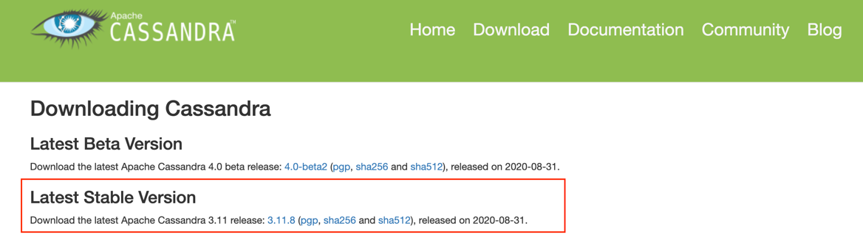

3.2 Extract downloaded file somewhere. For example, we extract and save at Download

Directory.

3.3 Start Cassandra in the foreground by invoking bin/cassandra -f from the command line. Press “Control-C” to stop Cassandra. For example:

$ cd C:\Users\pattama\Downloads\apache-cassandra-3.11.8\bin  
$ cassandra.bat -f

3.4 Open another command prompt and start cqlsh

$ cd C:\Users\pattama\Downloads\apache-cassandra-3.11.8\bin  
$ cqlsh

**For MacOS:**

1. Download and install the latest version of [Python 2.7](https://www.python.org/downloads/).

2. Download and install the latest version of [Java JRE 8](https://www.oracle.com/technetwork/java/javase/downloads/jre8-downloads-2133155.html). Click download file “jre-<version>-macosx-x64.dmg”.

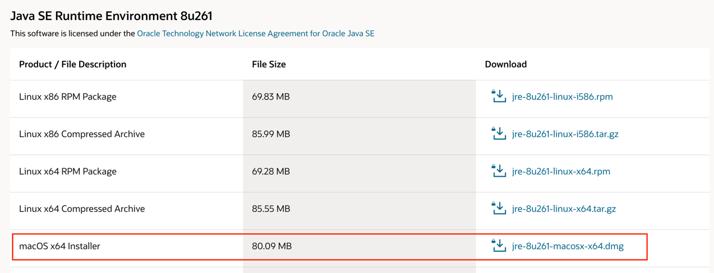

To verify java version in your machine, open terminal and type java -version.

3. Download and Install the latest stable version of Apache Cassandra

3.1 Download the latest stable version of Apache Cassandra at <http://cassandra.apache.org/download/>



3.2 Extract downloaded file somewhere. For example, we extract and save the extracted directory at Downloads directory.

3.3 Start Cassandra in the foreground by invoking bin/cassandra -f from the command line. Press “Control-C” to stop Cassandra. For example:

$ cd /Users/pattama/Downloads/apache-cassandra-3.11.8/bin  
$ ./cassandra -f

3.4. Open another terminal and start cqlsh

$ cd /Users/pattama/Downloads/apache-cassandra-3.11.8/bin

$ ./cqlsh

**For linux:** see the details of installation on this[**link**](https://www.youtube.com/watch?v=pGhkX5z_vW8&t=172s)

**References**:

1. Installing Cassandra on Windows: <https://www.youtube.com/watch?v=EEXtVn3zAqc&list=PLalrWAGybpB-L1PGA-NfFu2uiWHEsdscD&index=3>
2. Installing Cassandra on MacOS: <https://www.youtube.com/watch?v=XyrDoak3YnI>
3. Installing Cassandra on Linux: <https://www.youtube.com/watch?v=pGhkX5z_vW8&list=PLalrWAGybpB-L1PGA-NfFu2uiWHEsdscD&index=4>